WHERE:
The WHERE clause is used to filter records.
It is used to extract only those records that fulfill a specified condition.
We define condition in WHERE clause with SELECT keyword. --------------
Syntax:
SELECT column1, column2, ... OR * (means all columns)
FROM table_name
WHERE condition;
Example:
SELECT * FROM Customers
WHERE Country='Mexico';
Note: The WHERE clause is not only used in SELECT statements, it is also used in UPDATE, DELETE, etc.!
Operators in The WHERE Clause:
We can use operators in WHERE clause.
Example:
Select all customers with a CustomerID greater than 80:
SELECT * FROM Customers
WHERE CustomerID > 80;
The following operators can be used in the WHERE clause:
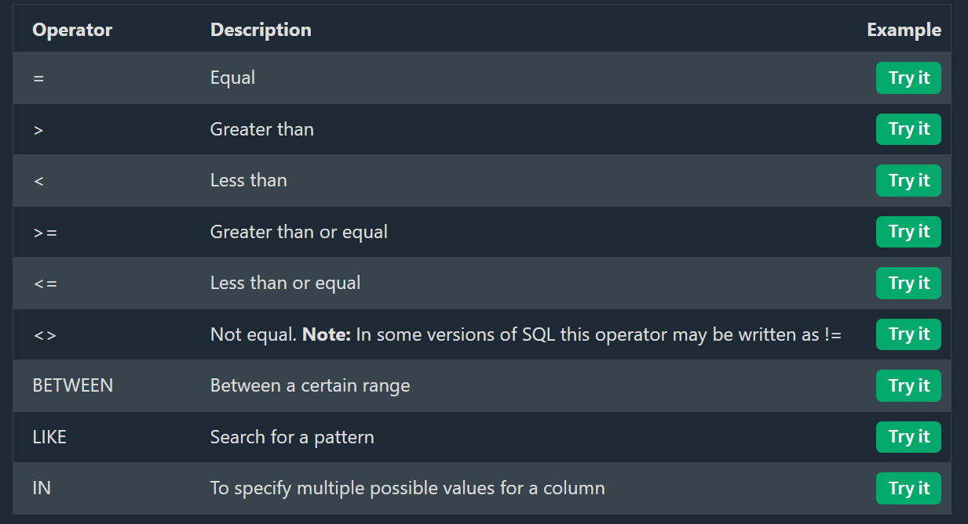
Exercise:
What is the purpose of the SQL WHERE clause?
To filter records that meet a specified condition.

